# Implementation:

1. **Python Keylogger Attack and Keylogger Tool Step 1:** Install python package using the command

conda install -c conda-forge pynput OR pip3 install pynput

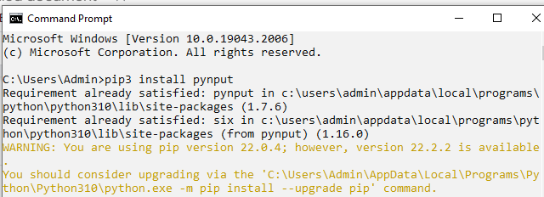

**Step 2:** Write the code and save it with .py extension

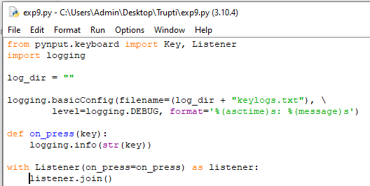

**Step 3:** Run this code and type anything on the keyboard

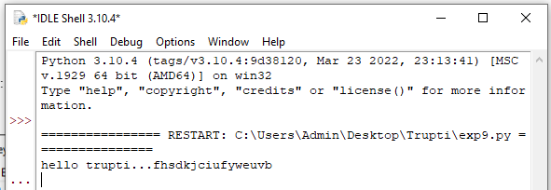

**Step 4:** Check a new file created in your folder named as keylogs

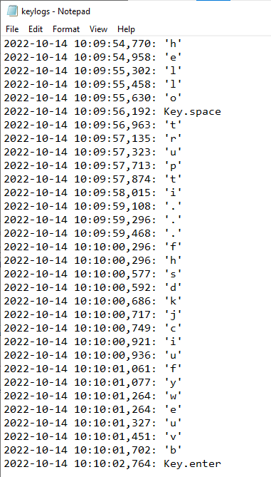

# Use the NESSUS/ISO Ubuntu tool to scan the network for vulnerabilities.

Acquiring Nessus:

[Go to https://www.tenable.com/products/nessus/nessus-professional/evaluate](http://www.tenable.com/products/nessus/nessus-professional/evaluate) to access the Nessus’ website to get the trial code to install Nessus.

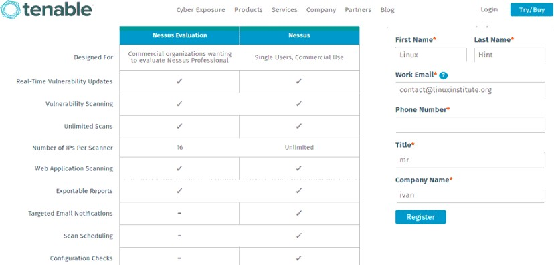

Fill the form to get your trial code by email, click on the “Download and install” link.

After returning to Nessus’ page you can select the proper version for your test. Select your version, accept the license terms and download.

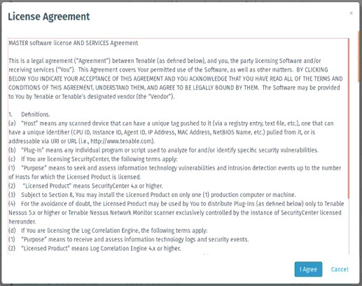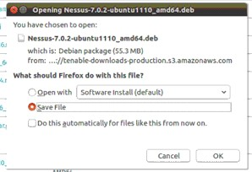

Installing Nessus:

Installing Nessus is very easy, especially if you have read our tutorial on DPKG packages manager.

Run: sudo dpkg -i

And after the installation is done follow the instructions by running: sudo /etc/init.d/nessusd start

Your terminal should show very similar results to the following:

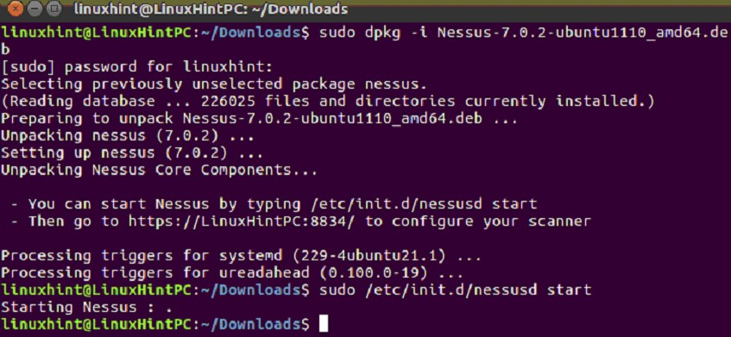

Following Nessus’ installation instructions lets go to: https://YOURPCNAME:8443 (change YOURPCNOW for your computer’s name, works with localhost too).

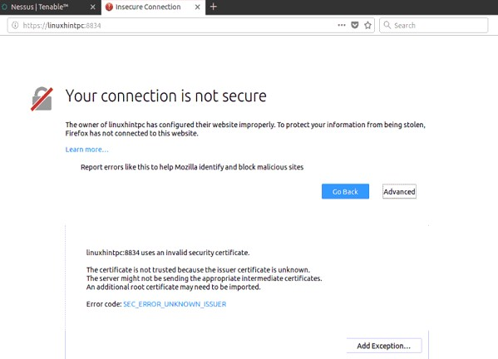

When opening the Web interface, a SSL error may appear. Just add an exception and continue accessing:

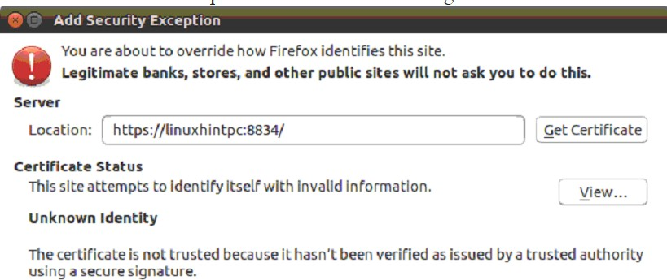

Finally we’ll meet Nessus’ screen, login using “admin” both as user and password.

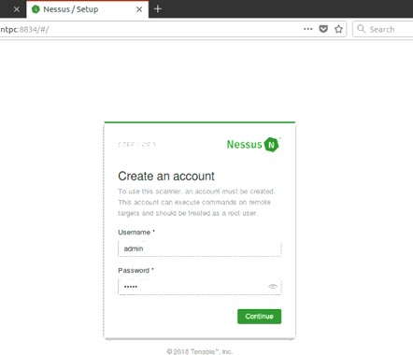

In the next screen select the use you’ll give to Nessus and put the trial code you got by e-mail.

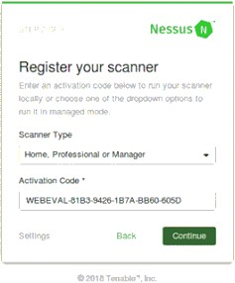

After filling everything Nessus will start initializing as shown in the next image, this step may take about 20 or 30 minutes, after finishing the next screen will be:

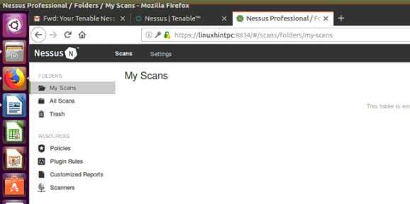

Scanning using Nessus: To create a new scan, click New Scan icon.

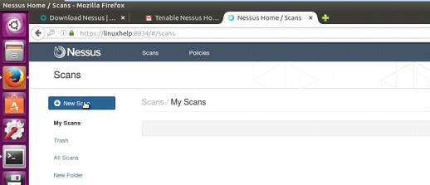

Select the type of scan.

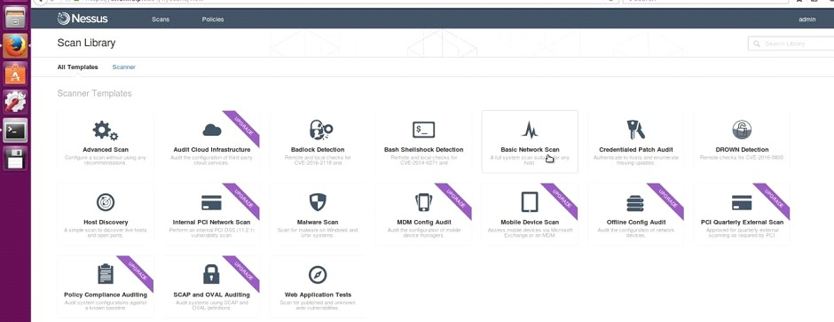

Enter the details of the system where the scan is to be performed.

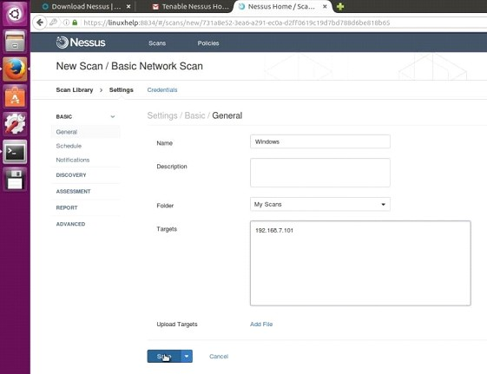

Select the scan and click the drop-down more and then launch the scan.

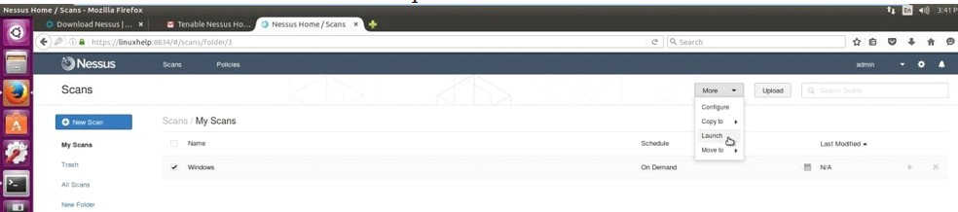

Select the scan to see the vulnerabilities in the target system.

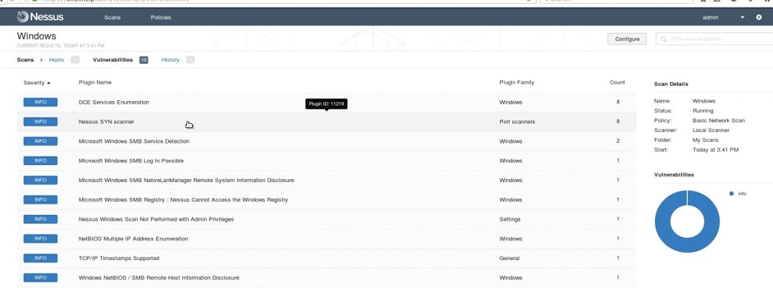

Click the vulnerability to see the description and solution for the vulnerabilities.

